**Lecture Note : Numerical Analysis (13) Newton-Cotes Integration Formula**

1. **Introduction to the Numerical Integration and Newton-Cotes Integration**

* Numerical Integration

 where is the approximating function

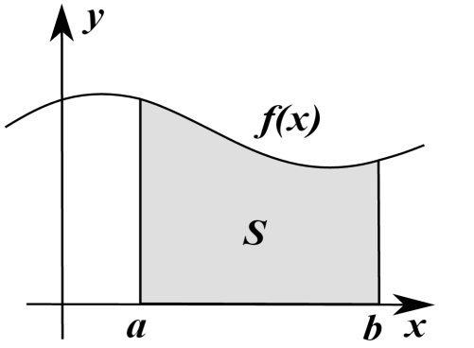

* Exact Integration of Polynomials and Newton-Cotes Integration



For



**The Newton-Cotes integration method approximates with interpolating polynomials to numerically calculate the integration of**.

1. **Divided-Difference Interpolation Formula revisited and Integration**

* **nth order polynomial interpolation function can be defined using the divided-difference formula as**



In general, if we define the following divided difference formula,

0th order: 

1st order: 

2nd order: 

…….

nth order: 

* In case of equal spacing such as 

- 1st order with two points 





**Trapezoidal Formula** 

- 2nd order with three points 





**Simpson’s 1/3 Rule** 

- 3rd order with four points 







**Simpson’s 3/8 Rule** 

1. **Multiple Application of Newton-Cotes Integration Formula**

**Trapezoidal Formula** 

**Simpson’s 1/3 Rule** 

**Simpson’s 3/8 Rule** 

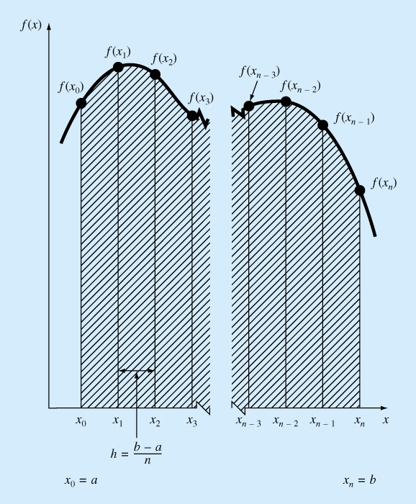

**(3-1) Trapezoidal**



**(3-2) Simpson’s 1/3 Rule**





**(3-3) Simpson’s 8/3 Rule**





1. **Integration With unequal segments**

* **By using the divided-difference formula, we can drive the related formula**



